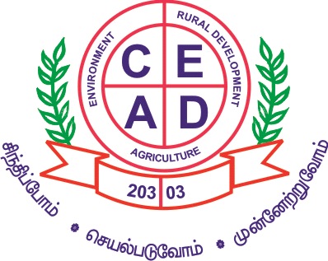
Centre for Environment and Agricultural Development (CEAD)
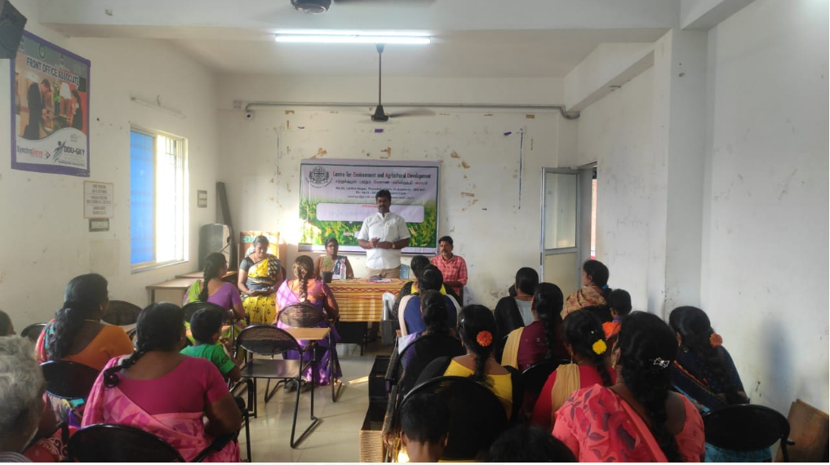

Annual Report Apr 2019 - March 2023

Regd. Office
72, Nallavadu Road, Thavalakuppam, Pondicherry – 605007

Admin. Office
No. 82, Lalithanagar,Thavalakuppam, Pondicherry- 605007
ceadngo@gmail.com, www.cead.org.in Cell: 098943 13435

About CEAD:
CEAD - Centre for Environmental and Agricultural Development, is an NGO which serves as a lab to land with the pursuit of betterment of Farmers and Women. Mainly to improve the quality of the deprived sectors (Farmers, Women, Youth, Students and Children) life by sustainable development. CEAD aims to achieve the goal through effective implementation of the rural and urban developmental programmes utilizing the local resources with people centric approach. CEAD is conceding its endeavors for improving socio-economic condition by undertaking the issues like Environmental Protection, Agriculture Development, Horticulture, Animal Husbandry, Health and Hygiene, Poverty, Capacity Building, Youth Development, Natural Resource Management, Watershed Resource Development and other developmental concerns.
CEAD acts as a bridge between this network of Agricultural Community and various other stake- holders of this sector (State and Central Governments, International Organizations, Bilateral Developmental agencies, Corporate, Academia, and End-users) through large-scale projects on the field. CEAD has also broadened its horizon recently in other rural development areas like Skill development, Micro-Irrigation Systems and Improvising Urban and Rural Healthcare through Producing and Marketing of Organic Products. CEAD has dedicated full time Staffs and Field Offices also.
CEAD is the Parental Organization guiding Green Day Producer’s Association and Pondicherry Institute of Agricultural Sciences working for the cause and care of deprived rural societies and improve their quality of life through Agricultural Education, Integrating programs and services, and consciously moving from Welfare towards Development and long term Sustainability.
Focus Area
- Agriculture
- Women Empowerment
- Livelihood
- Environment
- Agrotourism
- Education

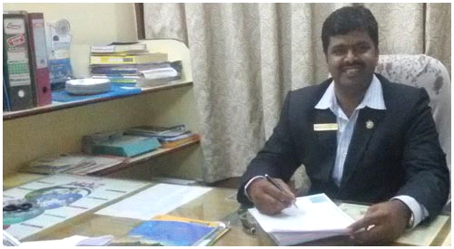Foreword from Director
C. Ganeche, ,M.Sc (Agri), Ph.D( Envt),
Founder & Director
Centre for Environment and Agricultural Development - CEAD

I am delighted to report that this year (2019- 23) we have been remarkably successful in achieving our purpose and goals.During the lockdown period CEAD has been spreading awareness, distributing relief materials and advocating for the access and availability of services to the communities and children. Awareness-building programs covered topics like social-distancing, best practices related to public health and hygiene and behavior change, sanitisation, use of face masks, following government guidelines during the lockdown period and ways to protect people from community spreading of the epidemic.And online training for Organic -Terrace garden & Nursery garden training given to people, through this training people got following benefits
- Organic and healthy vegetables
- Free stress
- Some people sold the vegetables and green leafs got income

Our services continued to be used by Local and National Beneficiaries &particularly Rural and Urban population and Farmers Community. We have contributed to building philanthropic infrastructure, raised substantial resources for the not-for-profit sector. In addition, we have spent considerable time building our operational efficiency and crafted a Long Range Plan with clear goals.
Agriculture is the pulse of our country and by and large forms the backbone of our National Economy. However, in order to keep pace with the increasing population, the growth in Agricultural production should be Sustainable in the long run. Uncertainties of weather and Climate pose a major threat to food security of the country. Besides, uncertainty of Climate and Weather, expected climate change and extreme weather and climatic events such as severe Droughts Floods or Temperature often socks the Farming Community leading to declining Agricultural Production. Targeting Weather and Climate information in advance, Agriculture and other Collaborative Agencies jointly organized Farmer Awareness Programme with CEAD which is able to reduce uncertainty and risks of the farmers and helps in better decision making. It leads to better economic, social and environmental outcome for farmers.
My appreciation and thanks to our Board Members, Advisors, Staff Team, Donors, Partners and Beneficiaries. I have every confidence that CEAD will continue to provide giving solutions in the years to come and will provide valuable resources to the not-for-profit sector.
I wish all of our Team Members and our well-wishers all the best in their endeavor to render meaningful service to the Society in the continuing years.

C. Ganeche
Founder & Director – CEAD

Major Activities of CEAD during this Year: 2019 to 2023

CEAD has been spreading awareness, distributing relief materials and advocating for the access and availability of services to the communities and children for lockdown period (COVID)
CEAD is a Social service Voluntary Organization engaged in the development of farming communities particularly women and landless labourers through training them in environmentally sustainable income generation activities, introducing micro credit schemes and by improving their access to quality education and health services.
Terrace Garden Training:
Organic Terrace Gardening Training Benefits:
- Gardens provide a place for experiencing nature which is proven to benefit mental health, cognitive functioning and emotional well-being.

- Gardening reduces depression, anxiety, obesity and heart disease as well as increasing life satisfaction, quality of life and sense of community.

- Gardens are essential to supporting recovery from illness and merely looking at gardens can reduce stress, blood pressure and muscle tension
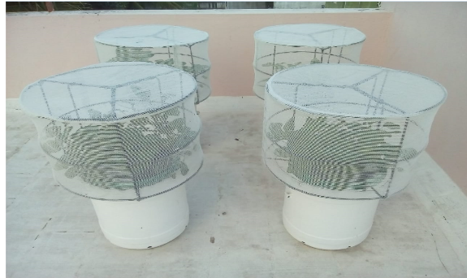

Vermi Compost Training :
The main objective of the organization is to promote sustainable agricultural practices for which vermi compost play pivotal role. Vermi compost is organic manure produced from the decomposable wastes and cow dung. It is easy to prepare, has excellent nutrient promoting properties and absolutely harmless to plants. As most of the reclamation process involves application of bio-manure for sustainable agricultural practices and also to restore the soil properties, now there is a constant demand for the vermi compost. Compost application increases the organic matter content in the soil and Soil pH is also altered. Producing vermicompost would be an alternate income generation activity for the landless and women. CEAD periodically conducts training to the landless women through experienced staffs helping them to learn the technology. During the current financial year 450 members were given training and more than 120 members had been involved in production and we have arranged market for the producers.
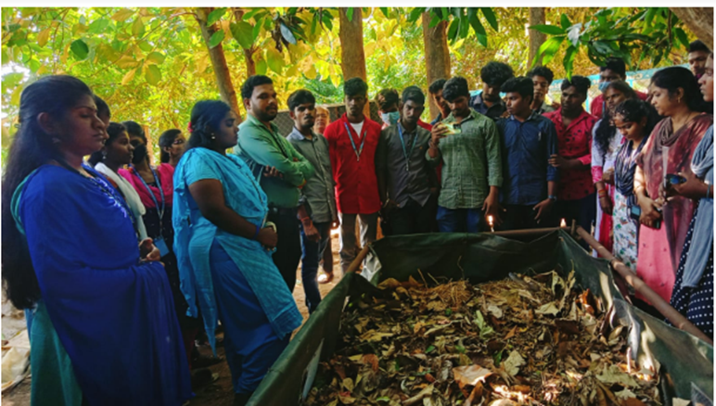
Mushroom Training:
Mushroom is protein rich consumable food which has now attracted most of the people as it has become one of the delicious dishes. Every month we have given mushroom training to interested people on various methods of production and the techniques involved in better mushroom growth. This programme aims at developing new income generation activity for the SHG members and Youth. During the last financial year nearly 196 members were imparted training. So for 24mushroom units were started after the training. We also facilitated the group to sell their products at Green day outlet, ulavarsandaiat Puducherry as well as restaurants and organic food shops like grande, bonapathi etc.
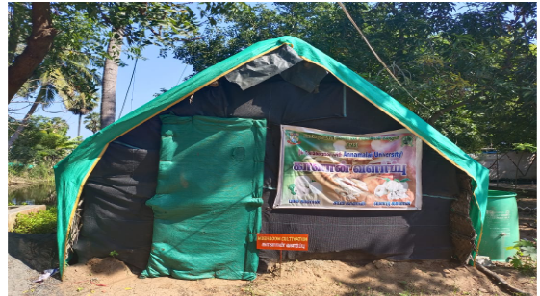
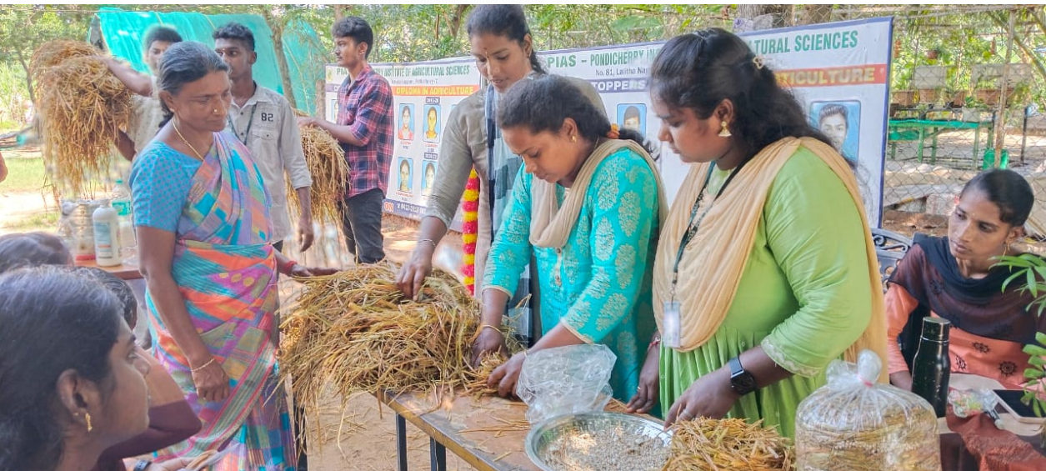

Organic Farming Awareness:
Agriculture - the backbone of our economy is being exploited through chemical usage and improper water management. This programme aims at increasing the capacity of the farmers in developing new methodologies and water management skills. As part of this programme, training is provided on integrated farming system and organic farming. In integrated farming system the various crops and related activities are explained and some farmers are in the process of developing IFS in their farm. In Organic farming, training is provided on usage of bio fertilizers and pesticides that does not alter the soil content and nature so that future generation will not be ruined. Also training is given on preparation of effective microoraganisms, Panchakaviya, Vermi wash, azolla culture and some trials are being conducted in the farmer’s field on research basis. Other than this training to School students and AgriculturalCollege students is also given related to organic farming and IFS. During this financial year 360 farmers and students were given training on organic farming practices.

ROOF TOP GARDEN
Apart from Funding from Funding agencies, CEAD has initiated Roof top Gardening Technique which has an objective of taking Agriculture into Urban people and ensure nutritive and quality vegetables intake.
Urban garden can have an overall positive impact on community health, which directly impacts individuals’ social and emotional well-being. There have been many documented cases in which community gardens lead to improved social relationships, increased community pride, and overall community improvement and mobilization. This improvement in overall community health can also be connected to decreased levels of crime and suicide rates
Urban gardens are often places that facilitate positive social interaction, which also contributes to overall social and emotional well-being. Many gardens facilitate the improvement of social networks within the communities that they are located. For many neighborhoods, gardens provide a “symbolic focus,” which leads to increased neighborhood pride.

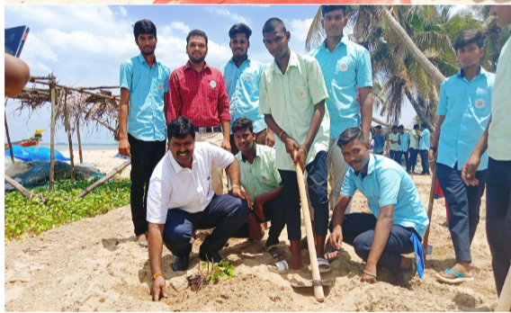

AGRICULTURE GRADUATES TRAINING PROGRAMME
Every year Agriculture graduates from PAJANCOA & RI, Annamalai University, and College of agriculture Development, Kalavai College of Agriculture visits CEAD for various programmes. CEAD has trained the students on Sustainable farming Practices, linked the Farmers for their course, Vermicompost production, Vegetable Seedling production, Agri business etc. As an output many of the graduates have become Agri- entrepreneurs. The following are the details of students visit to CEAD.
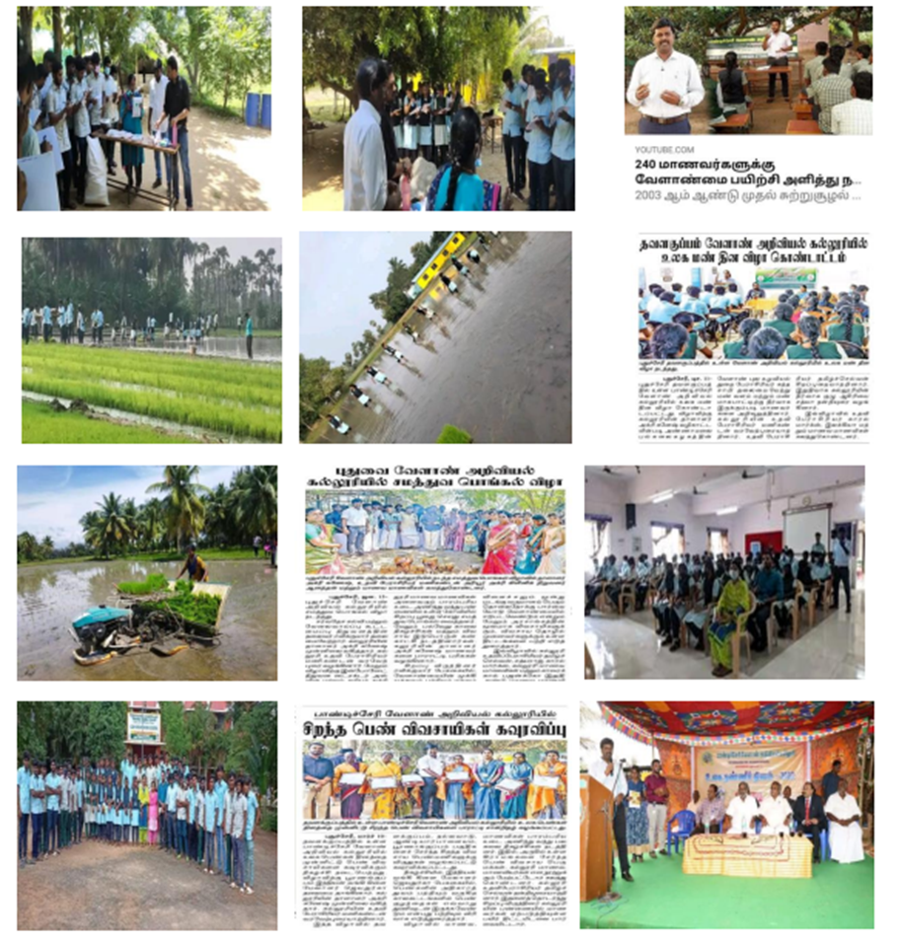
50 students from Annamalai University were placed for three months at CEAD for the Agri Business Management and NGO Attachment. Students were trained in various technology like Vermicomposting, Biofertilizer production, Roof Top Garden, and linked to Govt. Department of Agriculture and Allied sectors.
6 students from college of Agriculture Development were been here for NGO tie up programme for 15 days. The students were trained on NGO and legal procedures; they train the school students on Roof top garden.
60 students from PAJANCOA & RI had been at CEAD for NGO tie up programme for 15 days. They were involved in Organization Activities and designed a broucher for Roof Top garden. They also given Public Awareness on Roof top garden.
ENVIRONMENT
CEAD is working for Environment conservation since2003. Lot of tree plantations in public places as well as in schools were done. Created awareness among school childrens on Environment conservation by conducting quiz, essay writings, establishing solid waste composting pits in schools. This year we have done various new projects under Environment.
WORLD ENVIRONMENT DAY – 2021 & 2022
World Environment Day (also called as WED) has been started celebrating as an annual event on every 5th of June since 1973 in order to raise the global awareness about the importance of the healthy and green environment in the human lives, to solve the environmental issues by implementing some positive environmental actions as well as to make aware common public worldwide that everyone is responsible for saving his environment and not only somebody, government or organizations working for it.
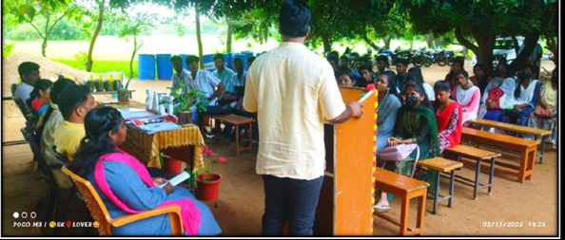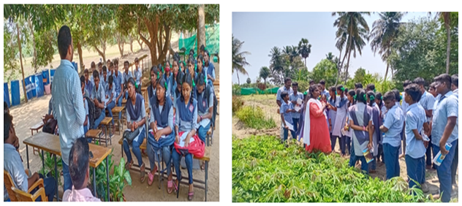

,
WOMEN EMPOWERMENT/ LIVELIHOOD DEVELOPMENT
CEAD has totally 120 SHG groups in Manaveli Commune of Puducherry. Various Enterpreneur trainings were given to them for their socially and economically upliftment. This year CEAD has given Training to Women of Science Backround education for their sustainable livelihood .
